**How To Submit Weights in Helical**

Login, and click on **“Import Data”**.

Then select the Weights Template you want.

Next Click **“Load Data”.** From here you can enter the data manually or..

Click **“Select Animals”** to select animals you wish to enter data for. You can use the filter to narrow your Selection of animals ie. Calving year. Ensure you click **the search icon** once you have selected your parameters for filtering.

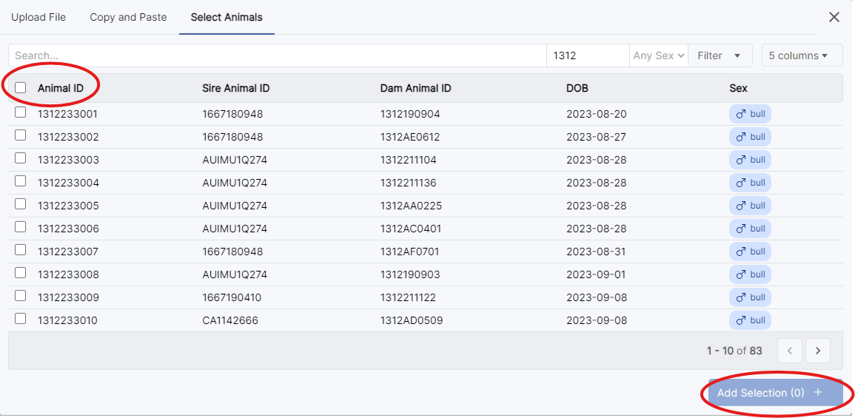If you wish to select all animals you have filtered, tick the box next to **“Animal ID”**, before clicking **“Add Selection”.** Alternatively, just select the animals you need to submit data for by ticking the boxes next to their Animal IDs and clicking **“Add Selection”.**

Once you have filled out the template with your weights, recording date, group and any docility scores, click **‘Next’**.

Click the green ‘creating’ button next to traits to review your weights. Then click **‘Submit’**. This will submit your weaning weights and docility scores to registry for approval.

Alternatively you can contact Registry for a Pre-built Excel Sheet.