**How to Transfer Animals in Helical**

Login, and click on **“Transfers”.**

Next, Click **“New Transfer”.**

Click **‘Advanced Options’** for the option to enter multiple transfer recipients or multiple transfer dates

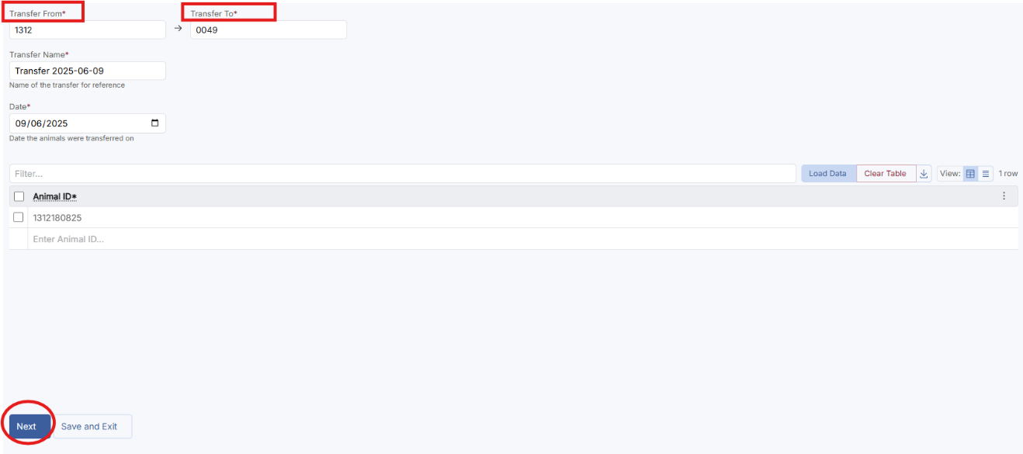Fill out the transfer form with the vendor member ID (“Transfer From”), purchaser member ID (“Transfer To”), Animal ID and date of sale. Then click **“Next”**

You will then be taken to a terms and conditions page to double check the details of the transfer. You can then tick the **“I agree to the terms and conditions”** and then click **“Transfer”.**

