**How To Complete Your ADLs in Helical**

Login, and click on **‘Import Data’**.

Select **‘ADLs’.**

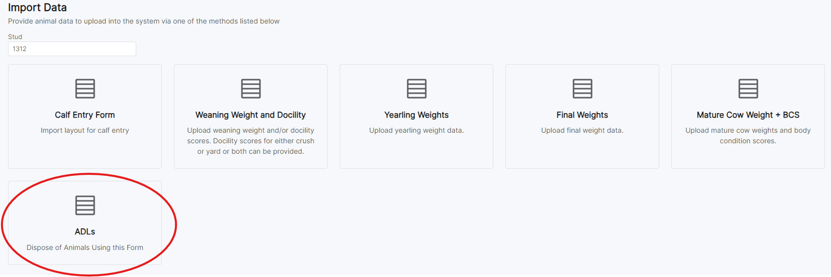

Next Click **‘Load Data’.**

Click **“Select Animals”** to select animals you wish to fate off. Here you can **“filter”** on the animals in your herd.

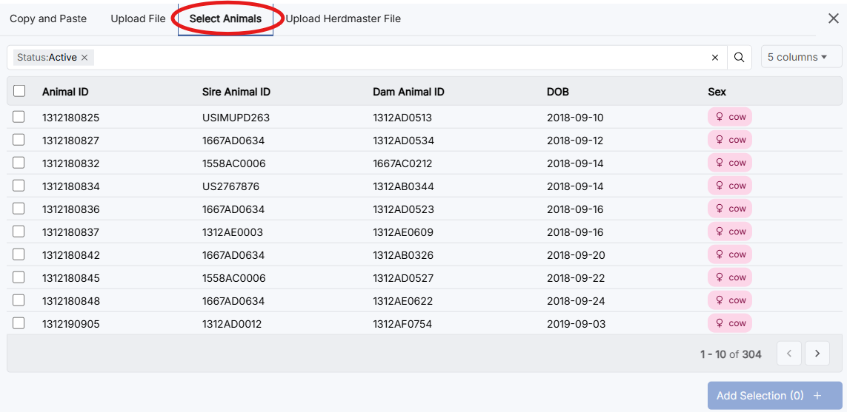

You can use the filter to narrow your Selection of animals ie. Calving year. Ensure you click **the search icon** once you have selected your parameters for filtering.

If you wish to select all animals you have filtered, tick the box next to **“Animal ID”**, before clicking **“Add Selection”.** Alternatively, just select the animals you need to dispose of by ticking the boxes next to their Animal IDs and clicking **“Add Selection”.**

Next fill in the **‘Disposal Code’** and **‘Disposal Date’**

Click **“More Help”** for the disposal codes.

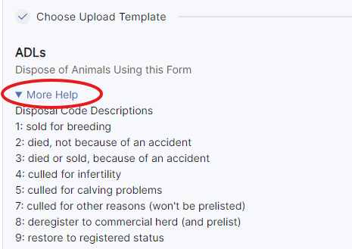

If you input the dates in the incorrect format, click the 3 dot icon in the left hand corner of the ‘Disposal Date’ field, and click **‘format’.** This will format all dates to the correct format.

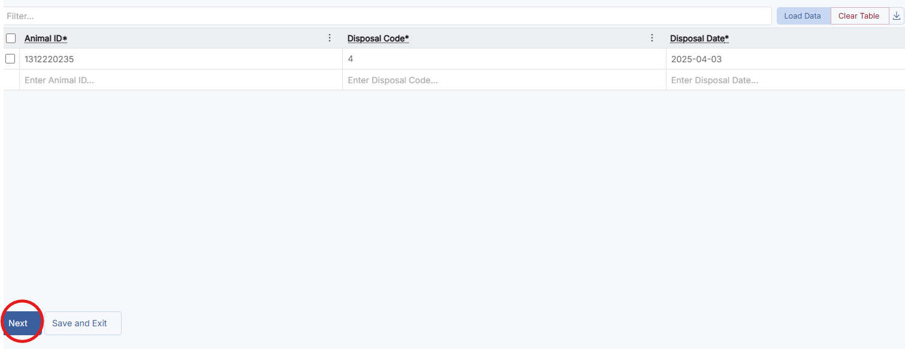Once all fields are completed, click **‘Next’.**

This will take you to a page to review the animals you are fating off. Click the blue ‘updating’ box to review your submission. Once you have checked the animal and disposal details, select **‘Submit’.** This will record the disposals for the registry team to approve.

