**How To Submit Calf Entries in Helical**

Login, and click on **“Import Data”**.

Select the **‘Calf Entry Form’**

To pre-fill the list with your dams, select **‘Load Data’.**

Click **‘select dam’**, then filter on status **‘active’** or any other fields you wish to filter on, and hit **the search icon.**

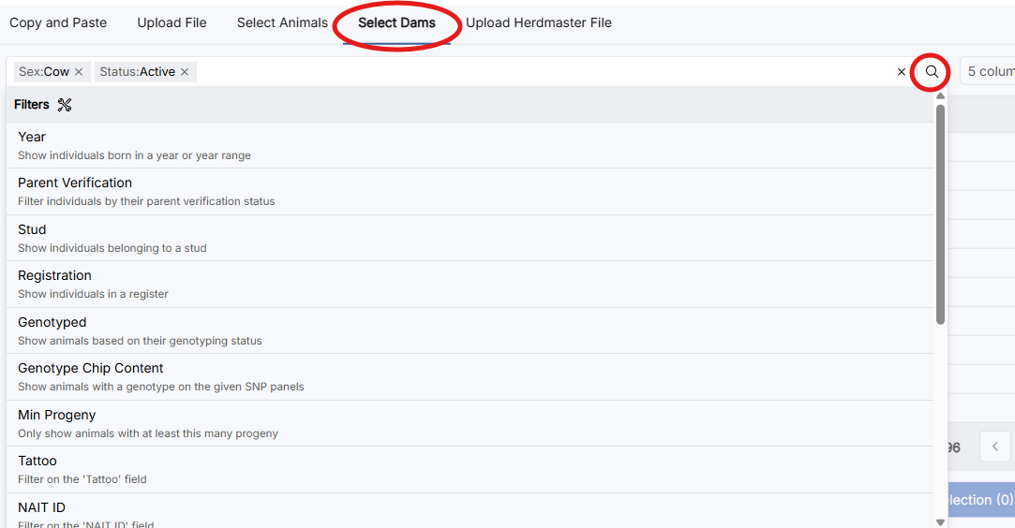

This will bring up a list of your active dams to choose from. Tick the dams you want.

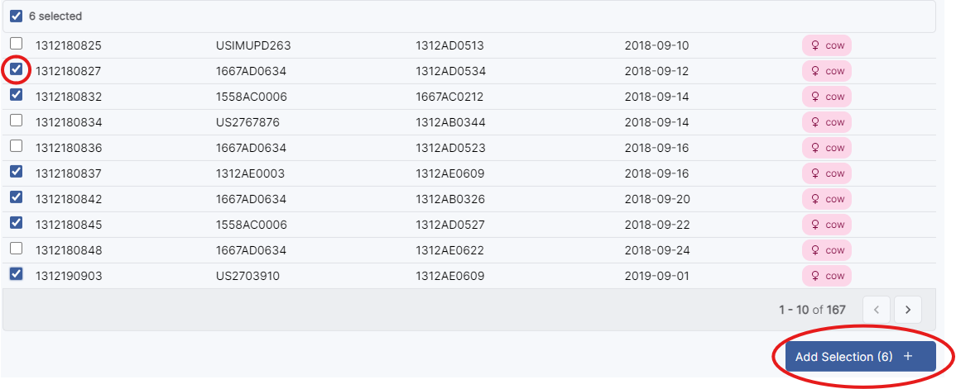

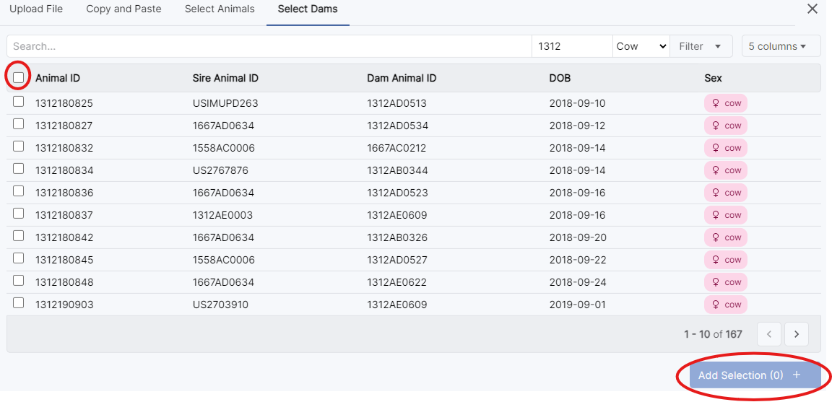**OR** select the tick box next to the ‘Animal ID’ to select all the dams you filtered on. Remember to click **‘Add selection’** after you have finished selecting your dams.

Once you have pre-filled the sheet with your dams, select the vertical lines icon in the right hand corner for a table view to enter calf details. To open the record, click the red exclamation point next to the dam ID.

Enter the details for each calf. All required fields are in red. Click **‘Next Row’** to move to the next record.

* Please note your stud prefix will automatically add to your animals’ names in the next step

Once you have recorded the calves, select ‘**Next’.**

Any errors will then show in a red box, with the number of errors indicated in the top corner. The errors need to be corrected before you can submit your calf entries.

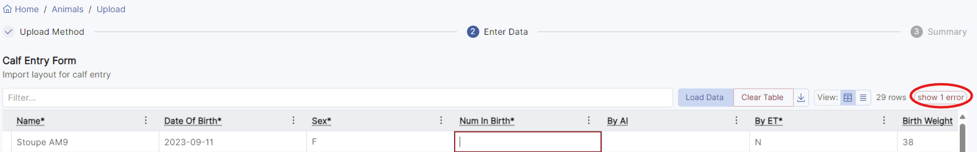

Click the green **‘creating’** button to review your entries. Then click **‘Submit’**. This will create a pending registration file for the PBB registry team to approve.

* A screenshot of a computer

  Description automatically generatedThroughout the registration stage, you can click the **‘save and exit’** button to return to the entries later.